Functional Equations

Equations for unknown functions are called functional equations. Questions involving equations of unknown sequences or polynomials can also be treated as problems of this kind, for sequences and polynomials are just special functions. Unfortunately, we have no systematic method or algorithm to solve general functional equations; and because of this, functional equations appear quite often in mathematics competitions.

1. Basic techniques in solving functional equations in one variable

Simple functional equations can be easily solved by a suitable transformation of variables:

Example 1.1
Solve the functional equation f(x + 1) = x² − 3x + 2.

Soln:
Let t = x + 1, then x = t − 1.
f(t) =(t − 1)² − 3(t − 1) + 2 = t² − 5t + 6
⇒ f(x) = x² − 5x + 6

Example 1.2
Solve the functional equation 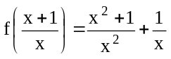.

Soln:
Let t =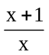, then x =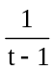.
Thus f(t) =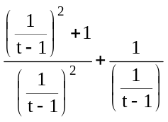= t² − t + 1
⇒ f(x) = x² − x + 1.

In general, suppose we want to solve the equation f [ϕ(x)] = g(x) for f.
If the inverse function of ϕ exists, then we let t = ϕ(x). Hence f(x) = g [ϕ⁻¹ (x)].

Example 1.3
Solve f(e^{x} ) = x³ + sin x for f.

Soln:
Let t = e^{x} , then x = ln t.
So f(x) = (ln |x|)³ + sin (ln |x|).

Example 1.4
Let a ≠ ±1. Solve 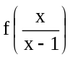 = af(x) + ϕ(x) for f.

Soln:
Let t =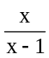, then x =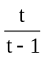.
f (t) = a f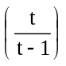+ ϕ = a(af(t) + ϕ(t)) + ϕ ⇒ f(x) =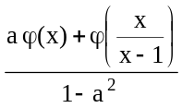

A functional equation in one variable may involve functional values of different algebraic expressions of the variable. A usually employed technique is to create simultaneous equations:

Example 1.5
Solve 3f(x) + 2f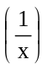 = 4x for f.

Soln:
Given 3f(x) + 2f= 4x. ------ (1)
Replace x byin the equation, we have
3f + 2f(x) =. ------ (2)
Solving (1) and (2), we have
f(x) =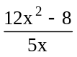.

Example 1.6
Find all real valued functions f defined on real numbers except 0 such that
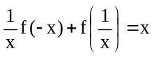 for all x ≠ 0.

Soln:
Replace x by −x, we have
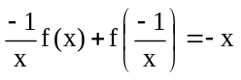 ----- (1)
Replace x by, we have
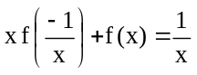 ----- (2)
Solve for f(x) from (1) and (2), we have 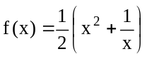.

It is often easy to find the solutions of functional equations with some additional properties or of special kinds. For example, the functions involved are continuous, monotonic, bounded, differentiable, polynomials etc.

Example 1.7
Given that f is a polynomial in x, solve the functional equation f(x + 1) + f(x − 1) = 2x² − 4x.

Soln:
Observe that deg (f(x)) = deg (f(x + 1) + f(x − 1)) = 2.
We may write f(x) = ax² + bx + c.
Substitute this into the functional equation, we have
2ax² + 2bx + 2(a + c) = 2x² − 4x.
By comparing coefficients,
2a = 2, 2b = −4 and 2(a + c) = 0.
Thus a = 1, b = −2, c = −1.
That is f(x) = x² − 2x − 1.

Exercise

1. Find the function f which satisfies f(x) + f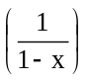 = x for all x ≠ 0, 1.

2. Which function is characterized by the equation xf(x) + 2xf(−x) = −1?

3. Find all polynomials p satisfying p(x + 1) = p(x) + 2x + 1.

4. Solve f(−tan x) + 2 f(tan x) = sin 2x for f , where 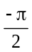 < x <.

5. Find continuous function f such that f(x) =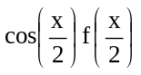 and f(0) = 1.

2. Functional equations in more then one variable

By looking for symmetry, some equations with more than one variable can be reduced to equations with one variable:

Example 2.1
Solve (x − y)f(x + y) − (x + y)f(x − y) = 4xy(x² − y²) for f.

Soln:
The equation is 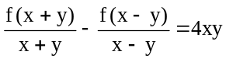.
Let g(x) =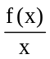.
Then g(x + y) − g(x − y) = 4xy
⇒ g(x + y) − (x + y)² = g(x − y) − (x − y)²
⇒ g(x) − x² = k for some constant k
⇒ f(x) = x³ + kx

Another way to reduce the number of variables involved is to assign special values to some variables in the equations:

Example 2.2 [87-88 IMO(HK) Selection Contest]
If f(x)f(y) − f(xy) = x + y for all real x and y, find f(x).

Soln:
Setting y = 0, we have f(0)(f(x)−1) = x for all x.
Thus f(0) ≠ 0 and 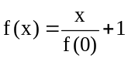.
Setting x = 0 = y ⇒ f (0) (f (0) −1) = 0 ⇒ f (0) = 1
∴ f (x) = x + 1
Finally, since (x+1)(y+1)−(xy+1) = x + y, the solution is verified.

Example 2.3 [95-96 IMO(HK) Selection Contest]
The function f satisfies f(x) + f(y) = f(x + y) − xy − 1 for every real x, y.
If f(1) = 1, find the negative integer n such that f(n) = n.

Soln:
Let x = 1, then f(y + 1) − f(y) = y + 2. Let y = 0, then f(0) = −1.
For n ≥ 1, f(n) + 1 = f(n) − f(0) =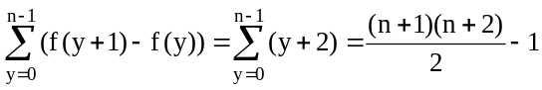
⇒ f(n) =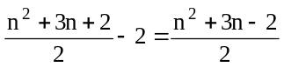
Let x = n, y = −n, we have f(n) + f(−n) = n² − 2 ⇒ f(−n) = n² − 2 − f(n) =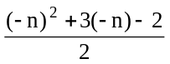
It follows that f(n) =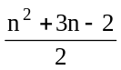 holds also for negative n.
∴ f(n) = n ⇔ = n ⇔ n² + n − 2 = (n −1)(n + 2) = 0 ⇔ n = 1 or −2

Some Useful Results
Let f be a continuous function.
(1) f(x + y) = f(x) + f(y) for all x, y (Additive)
⇒ f(x) = cx
(2) f(x + y) = f(x)f(y) for all x, y
⇒ f(x) = c^{x}
(3) f(xy) = f(x) + f(y) for all x, y
⇒ f(x) = c ln x
(4) f(xy) = f(x)f(y) for all x, y (Multiplicative)
⇒ f(x) = x^{c}
where c is a constant.

Example 2.4 (Jensen's functional equation)
Find all continuous functions f such that 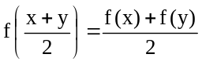 for all x, y ∈ R.

Soln:
Set y = 0, we have 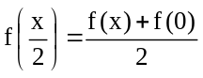 for all x.
Then 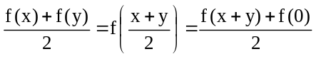 for all x, y. i.e. f(x + y) = f(x) + f(y) − f(0)
Let h(x) = f(x) − f(0), then h(x + y) = h(x) + h(y) for all x, y.
Hence h(x) = cx for all x; and so f(x) = cx + f(0) for all x.

Example 2.5
Find all continuous solution(s) of f(x + y) = g(x) + h(y).

Soln:
Set y = 0, h(0) = b, we have f(x) = g(x) + b
Set x = 0, g(0) = a, we have f(y) = a + h(y)
It follows that f(x + y) = [f(x) − b] + [f(y) − a] = f(x) + f(y) − (a + b).
Let F(x) = f(x) − a − b.
Then F(x + y) = F(x) + F(y).
⇒ F is an additive continuous function, so F(x) = kx k - constant.
Consequently,
f(x) = kx + a + b; g(x) = kx + a and h(x) = kx + b

Exercise
6. The function f(x) is defined for all real x. If f(a + b) = f(ab) for all a, b and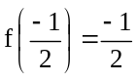, compute f(1988). [88-89 IMO(HK) Selection Contest]

7. Let f be a function such that
f(x + y²) = f(x) + 2(f(y))² and f(1) ≠ 0.
Find the value of f(1996).
[96-97 IMO(HK) Selection Contest]

8. Find all solutions of f(x + y) + f(x − y) = 2f(x)cos y.

9. Find all continuous function f defined for x > 0 such that f(xy) = xf(y) + yf(x).

10. Find all continuous function f defined for x > 0 such that f(x + y) =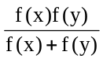.

11. Find all continuous functions f satisfying f(x + y) = f(x) + f(y) + f(x)f(y).

3. Harder Functional Equations

To solve a functional equation of IMO-type is not easy. The technique discussed is helpful but not sufficient. The good thing about trying a problem in functional equation is that one can pluck in a lot of values to get some properties of the function. However, you need to have a sense of discernment:
(1) Is the function one-to-one or onto?
(2) Is the function periodic, even or odd?
(3) Is the function increasing/decreasing?
(4) Is there any symmetry?
(5) Is there any fixed point?
(6) What is the significant of other conditions?

Example 3.1 [IMO 1968]
Let f be a real-valued function defined for all real numbers x such that, for some positive constant a, the equation f(x + a) =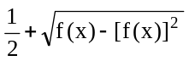 holds for all x.
(a) Prove that the function f is periodic.
(i.e. there exists a positive number b such that f(x + b) = f(x) for all x).
(b) For a = 1, give an example of a non-constant function with the required properties.

Idea:
The equation is f(x + a) −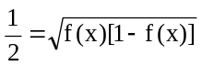. Can you observe that both sides are "symmetrical about 1/2"? If you recognize this fact, it is natural to use the substitution g(x) = f(x) − 1/2.

Soln:
Let g(x) = f(x) − 1/2. Then g(x) ≥ 0 and 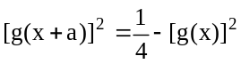 for all x.
It follows that 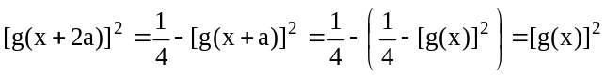 ⇒ g(x + 2a) = g(x) for all x.
Thus f(x + 2a) = g(x + 2a) + 1/2 = g(x) + 1/2 = f(x) for all x, so f is periodic with period 2a.
For a = 1, an example of a non-constant function with the required properties is
f(x) =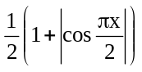
Indeed, f(x + 1) =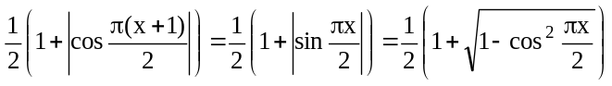
=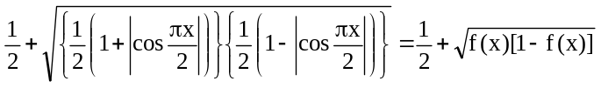
Example 3.2
Let f: N → N be strictly increasing, f(2) = 2, and
f(mn) = f(m)f(n) for all m, n ∈ N with (m, n) = 1 (m, n coprime).
Prove that f(n) = n for all n ∈ N.

Idea:
It is easy to check that f(1) = 1. Furthermore, if m is an odd integer, (2, m) = 1 and so f(2m) = f(2)f(m) = 2f(m).
Therefore, if f(m) = m for some odd integers, f(2m) = 2m.

Soln:
First, 2f(1) = f(1)f(2) = f(1×2) = f(2) = 2 ⇒ f(1) = 1.
Second, 2f(7) = f(2)f(7) < f(3)f(7) = f(21) < f(22) = f(2)f(11) = 2f(11) < 2f(14) = 2f(2)f(7) = 4f(7) ⇒ f(3) = 3.
Suppose there are some positive integers n with f(n) ≠ n and we let s be the smallest among them.
Then f(n) = n for n ≤ s − 1.
Since f(s) ≠ s and f is strictly increasing, f(n) > n for n ≥ s ----- (*)
Case (i)
If s is odd, then (2, s − 2) = 1 and so 2(s − 2)= f(2)f(s − 2) = f[2(s − 2)].
However, for s ≥ 4, 2(s − 2) ≥ s and so f[2(s − 2)] > 2(s − 2) which contradicts to (*).
Case (ii)
If s is even, then (2, s − 1) = 1 and so 2(s − 1) = f(2)f(s − 1) = f[2(s − 1)].
However, for s ≥ 4, 2(s − 1) ≥ s and so f[2(s − 1)] > 2(s − 1) which contradicts to (*) again.
In conclusion, such an s does not exist, and hence f(n) = n for all positive integers n.

Example 3.3 [IMO 1977]
Let f(n) be a function defined on the set of all positive integers and having all its values in the same set.
Prove that if f(n + 1) > f(f(n)) for each positive integer n, then f(n) = n for each n.

Idea:
What we are given is an inequality. Hence we shall show f(n) ≥ n and f(n) ≤ n. First, it is clear that f(1) ≥ 1 and f(2) > f(f(1)) ≥ 1 ⇒ f(2) ≥ 2. However, we cannot deduce f(3) ≥ 3 from f(3) > f(f(2)) because we only know that f(2) ≥ 2 but we don't know whether f(f(2)) ≥ 2. In view of this, we shall show a much stronger assertion: "If m is an integer greater than or equal to n, then f(m) ≥ n" by induction on n.

Soln:
Let P(n): If m ≥ n, then f(m) ≥ n.
Clearly we have f(m) ≥ 1 for all m ≥ 1.
Assume P(n) is true. i.e. If m ≥ n, then f(m) ≥ n.
Now m ≥ n + 1 ⇒ m − 1 ≥ n ⇒ f(m − 1) ≥ n ⇒ f(f(m − 1)) ≥ n ⇒ f(m) > f(f(m − 1)) ≥ n
⇒ f(m) ≥ n + 1
∴ P(n + 1) is also true.
By induction, P(n) is true for all n ≥ 1.
In particular, f(n) ≥ n for all n ≥ 1.
Consequently, f(n + 1) > f(f(n)) ≥ f(n) proving that f is strictly increasing.
Now f(k) ≠ k for some k
⇒ f(k) > k ⇒ f(k) ≥ k + 1 ⇒ f(k + 1) > f(f(k)) ≥ f(k + 1) which is impossible.
Therefore, f(n) = n for all n.

Example 3.5 [IMO 1982]
The function f(n) is defined for all positive integers n and takes on non-negative integer values.
Also, for all m, n
f(m + n) − f(m) − f(n) = 0 or 1
f(2) = 0, f(3) > 0, and f(9999) = 3333.
Determine f(1982).

Idea:
We have f(m + n) − f(m) − f(n) ∈ {0, 1}. This is an ambiguous equation and is difficult to handle. It forces us to restate the condition as f(m + n) ≥ f(m) + f(n).
It is not difficult to get f(3) = 1 and hence f(2×3) ≥ 2f(3) = 2, f(3×3) = f(3 + 2×3) ≥ 3f(3) = 3, …, f(3n) ≥ 3n. The fact that f(9999) = 3333 implies that f(3n) = 3n holds at least up to n = 3333.

Soln:
We have 0 ≤ f(m + n) − f(m) − f(n) ≤ 1 for all m, n.
Thus f(m + n) ≥ f(m) + f(n) and f(m + n) ≤ f(m) + f(n) + 1 for all m, n.
Put m = n = 1, then f(2) ≥ 2f(1). But then f(2) = 0 forces f(1) = 0.
Put m = 2, n = 1, then 0 < f(3) ≤ f(2) + f(1) + 1 = 1 ⇒ f(3) = 1.
It follows easily from induction that f(3n) ≥ n for all n; and if f(3k) > k for some k, then f(3m) > m for all m ≥ k.
Since f(9999) = f(3×3333) = 3333, the equation f(3n) = n holds at least up to n = 3333.
Now 1982 = f(3×1982) ≥ f(2×1982) + f(1982) ≥ 3f(1982) ⇒ f(1982) ≤ 1982/3 < 661.
On the other hand, f(1982) ≥ f(1980) + f(2) = f(3×660) + 0 = 660.
It follows that f(1982) = 660.

Example 3.6 [IMO 1994]
Let S be the set of real number greater than −1. Find all functions f : S → S satisfying the two conditions:
(i) f(x + f(y) + xf(y)) = y + f(x) + yf(x) for all x, y in S;
(ii) is strictly increasing for −1 < x < 0 and for 0 < x.

Idea:
There seems to be a symmetrical among the variables x and y. We put x = y in (i) get:
f(x + f(x) + xf(x)) = x + f(x) + xf(x).
Therefore, for each x, the number x + f(x) + xf(x) is a fixed point of the function.
On the other hand, condition (ii) means has at most 3 fixed points.

Soln:
Put y = x in (i) ⇒ f(x + f(x) + xf(x)) = x + f(x) + xf(x) ⇒ x + f(x) + xf(x) is a fixed point of f.
Condition (ii) implies that f has at most 3 fixed points, one in the interval (−1, 0), one equal to 0, and one > 0.
Furthermore, if u is a fixed point of f, then by putting x = y = u in (i), we have f(u² + u) = u² + 2u.
Thus u² + 2u is also a fixed point.
(1) If f has a fixed-point u in the interval (−1, 0), then it follows from 0 < u + 1 < 1 that
−1 < u² + 2u = (u + 1)² − 1 < 0.
Both u and u² + 2u are fixed points in (−1, 0) ⇒ u = u² + 2u ⇒ u² + u = 0 ⇒ u = 0 or −1 which is impossible.
∴ f has no fixed point in the interval (−1, 0).
(2) If f has a fixed-point u > 0, then clearly u² + 2u > 0.
Hence both u and u² + 2u are positive fixed points ⇒ u = u² + 2u ⇒ u = 0 or −1 which is absurd again.
Consequently, the only fixed point of f is 0.
Thus x + f(x) + xf(x) = 0 for all x
That is, f(x) =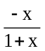

Example 3.7 [IMO 1983]
Find all functions f defined on the set of positive real numbers which take positive real values and satisfy the conditions:
(i) f(xf(y)) = yf(x) for all positive x, y;
(ii) f(x) → 0 as x → ∞.

Idea:
By setting x = y, we know that xf(x) is a fixed point of f for all x. Furthermore, we can show that the product of two fixed points is also a fixed point. Hence, given a fixed point a > 1, we can generate a sequence of fixed points: a, a², a³, …. This contradicts to the fact that f(x) → 0 as x → ∞, ….

Soln:
First, since 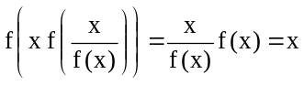 for all x > 0, the function is onto.
Let f(y) = 1.
Then f(1) = f(1×f(y)) = yf(1) ⇒ y = 1. Therefore, f(1) = 1.
By putting y = x in (i), we have f(xf(x)) = xf(x) for all x > 0 ⇒ For every x > 0, xf(x) is a fixed point of f.
Observe that:
(1) If a and b are fixed points of f, then f(ab) = f(af(b)) = bf(a) = ba. Hence ab is also a fixed point of f.
In particular [xf(x)]^{n} is a fixed point for n = 1, 2, 3, ….
(2) If a is a fixed point of f, then 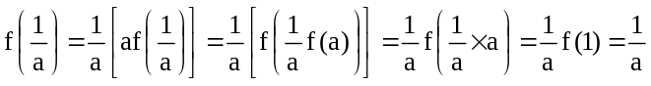.
Hence is also a fixed point.
Now if a > 1 is a fixed point, then by (1), f(a^{n}) = a^{n} → ∞ as n → ∞. This contradicts to condition (ii).
Moreover, by (2), a < 1 is a fixed point implies 1/a > 1 is a fixed point.
Consequently, the only fixed point of f is 1.
Therefore xf(x) = 1 for all x. That is, f(x) =.

Example 3.8 [IMO 1996]
Let S = {0, 1, 2, 3, …} be the set of non-negative integers. Find all functions f defined on S and taking their values in S such that f(m + f(n)) = f(f(m)) + f(n) for all m, n in S

Idea:
By putting m = n = 0, we gets f(0) = 0. Hence f(f(n)) = f(0 + f(n)) = f(f(0)) + f(n) = f(n) for all n. Therefore, all numbers of the form f(n) are fixed points.
Through the investigation of the properties of the fixed points, we should find that if p is the smallest positive fixed point of f, then the fixed points of f are precisely the integral multiple of p.
For any positive integer n, we can write n = kp + r with k ∈ S and 0 ≤ r < p. Then
f(n) = f(kp + r) = f(f(kp) + r) = f(kp) + f(r) = kp + f(r).
f is determined by its action on 1, 2, …, p − 1.

Soln:
Put m = n = 0, f(f(0)) = f(f(0)) + f(0) ⇒ f(0) = 0.
Put m = 0, f(f(n)) = f(f(0)) + f(n) = f(n)
Then all numbers of the form f(n) are fixed points, and hence for all m and n, f(m + f(n)) = f(m) + f(n) ---- (*)
Clearly f ≡ 0 is a solution.
We shall assume f is not identically zero and let p be the smallest positive fixed point of f.
If p = 1, then f(1) = 1 and f(1 + f(n)) = f(1) + f(n) = 1 + f(n) implies easily by induction that f(n) = n for all n.
If p > 1, f(p) = p ⇒ f(2p) = f(p + f(p)) = 2f(p) = 2p ⇒ f(3p) = f(p + f(2p)) = f(p) + f(2p) = 3p ⇒ … ⇒ all positive multiplies of p are fixed points.
Moreover, if b is a fixed point, write b = kp + r with r, k ∈ S and 0 ≤ r < p.
Then kp + r = f(kp + r) = f(f(kp) + r) = f(r) + f(kp) = kp + f(r) ⇒ f(r) = r. The minimality of p forces r = 0.
Hence, the fixed points of f are precisely 0, p, 2p, 3p, ….
For every n ∈ S, write n = kp + r with k, r ∈ S and 0 ≤ r < p.
Then f(n) = f(kp + r) = f(f(kp) + r) = f(r) + f(kp) = f(r) + kp.
Hence f is determined by its action on 1, 2, …, p − 1.
Since f(1), f(2), …, f(p − 1) are fixed points, each of them is a positive multiple of p. Consequently, after (p − 1) arbitrary non-negative integers are chosen, the values of f(1), f(2), …, f(p − 1), and all others f(n) are determined.

Exercise

12. Let f: R → R a function such that
(i) for all x, y ∈ R
f(x) + f(y) + 1 ≥ f(x + y) ≥ f(x) + f(y)
(ii) for all x ∈ [0, 1), f(0) ≥ f(x).
(iii) −f(−1) = f(1) = 1.
Find all such functions.

13. [IMO 1981]
The function f(x, y) satisfies
(1) f(0, y) = y + 1,
(2) f(x + 1, 0) = f(x, 1)
(3) f(x + 1, y + 1) = f(x, f(x + 1, y)),
for all non-negative integers x, y. Determine f(4, 1981).

14. Find all functions f: N∪{0} → N∪{0} satisfying the following two conditions:
(i) For any m, n ∈ N∪{0}, 2f(m² + n²) = {f(m)}² + {f(n)}²
(ii) For any m, n ∈ N∪{0} with m ≥ n, f(m²) ≥ f(n²).

15. Let f: N → N be such that f(f(m) + f(n)) = m + n for all m, n.
Prove that f(n) = n for all n ∈ N.

